Accessibility Forum Minutes 14/11/2024

**Introductions to the meeting with Attendees and Apologies**

* Aaron Buckingham Passenger Services Operations Manager
* Andy Alexander Terminal Manager
* Tom Elliott – PS Training and compliance Lead
* Emma Parnell- PS Duty Manager (Note Taker)
* Tara Hurst (Customer Operations Manager
* Dave Richardson Joint Accessibility Forum chair
* Allison Friday – Joint Accessibility Forum chair
* Linda Oliver – Guide Dogs Access Officer
* Roger Bessant – Linda’s support worker and partner
* Scott Davis - Customer
* Dianne Wilson – Customer
* Robin Raine – Customer

On Microsoft Teams meeting Introductions:

* Kerry Highcock – North East Autism Society
* Emily Kilby – Consumer Policy Advisor from the CAA

Apologies

Victoria Raine -Customer

Tracie Bestford -CLIP Hartlepool

Helen Mayne- Alzheimer’s society

**Airport Project Update**

Andy Alexander gave an update on all the airport projects and developments that will be commencing winter 2024. This included terminal improvements and commercial business partners refurbishments.

**Runway Project**

* £17 million pounds project currently underway to replace runway surface.

**Staff Lane upgrade**

* Upgrading the staff lane to follow alongside the central search area.
* A project to improve the customer journey and experience whilst also supporting the growing PRM service requirements. This will enable those customers who are assisted by the PRM team to be escorted directly to the Gate 19 assistance area, bypassing the longer journey through the terminal. The operational delivery and protocols for this are still under review and will be shared and rolled out once agreed.

**Refurbishments of the commercial outlets**

* Greggs – Upgrading the footprint and offerings
* JD Sports – New location and expanded store
* Bar 11 – Improved bar area and full refurbishment

**Gate 19 assistance lounge project**

* Over the next year to 18-24 months, we are looking to implement several improvements within the gate 19 lounge with phase one commencing November 2024 with the removal of the gate from the general boarding areas dedicating this to those customers requiring assistance.
* Plans under review and to be agreed upon include the install of lifts, changing places toilets, sensory area, remodel the whole area and make it a comfortable place for our passengers to wait for their flights.

**Other projects**

* Departure corridor – plans being reviewed to continue the development of the pier departure corridor to enhance the aesthetics and look of the area
* Gate capacity improvements – a restructure of several of the gates to create capacity during the peak departures improving the customer journey, this includes queue management areas and new desk facilities.

**Awards and recognition**

**Best Airport in the World Award – The only UK airport to win it and won the whole world award.**

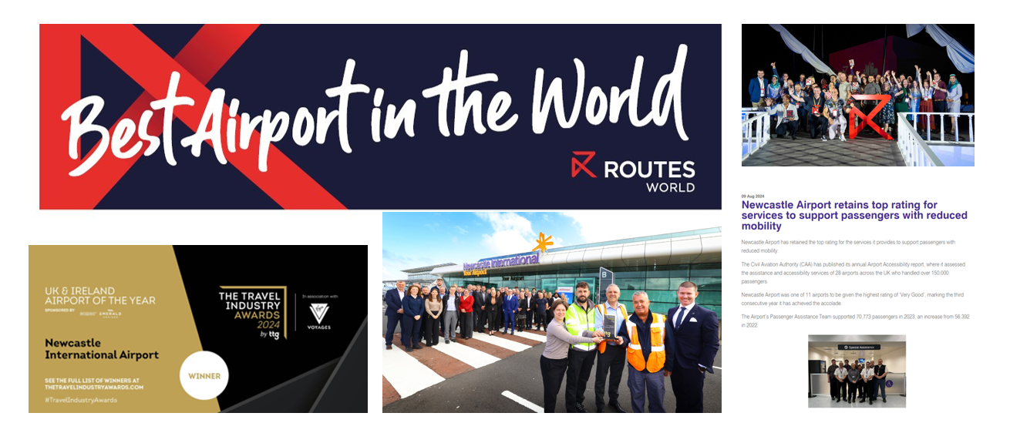

**Airport Tour**

1. Assistance Area

No points to note

1. Security

Request to introduce more seating at the security tray area for passengers to sit down to take off shoes/boots. A review will be undertaken and feasibility for this to be introduced by the security compliance team and terminal team.

1. Departures

Tap & Brew – The group advised the area was difficult to navigate through with wheelchairs due to mass seating.

1. Aspire Lounge

No points to note

1. Gate 19 Lounge

New Thunderlift - electric ambulift vehicle for assisting customers, currently NIA have two with a third being delivered in December 2024

Gate 19 proposal and developments

Sensory area

UKBF direct access corridor

Changing Places toilet

1. UK Border Force

The team gave the group an explanation on how the direct access route from the assistance lounge to the UKBF area and how this would support the customer journey via the gate 19 assistance lounge.

**

**Break for lunch and open table discussion**

The Group discussed possible misuse of the service and how this could possibly be mitigated going forward.

Discussion around the one passenger requiring assistance with one party member rule and also around the use of the staff lane.

Discussion around the 30% increase in passengers requiring assistance.

Discussion around training for assisting blind / visually imparted people.

**AB begins with the PowerPoint again after lunch break.**

* CAA Accessibility Report 2023 – Newcastle Airport was rated Very Good. 
* New Equipment – Airport is aiming to be Net Carbon zero by 2025.
* Our team is undergoing disability awareness training during their refresher training. David and Ryan attending the training courses from Unsilence the Crowd giving their experience from their side as they are both deaf.
* Tara and Aaron attended DNEE Purple Tuesday and they have filmed some of their journey through the airport.

**Discussion around the table:**

Discussion around the call points in the car parks are the wrong color. Harmonisation of car park call points. Ours are green and orange and univerally should be blue, a review of these should take pace .

// Photographs of our orange / green car park help points.

Discussion around Pre-Notification

Aviation Accessbility Task and Finish Group

**Actions:**

* Organising with Guide Dogs charity for someone to come in and give their training.
* Car park call point colour to be reviewed.
* Seating to be reviewed in the security search area .

Thank you for your attendance, we look forward to seeing you on the next one.

Next Meeting Proposed Date:

13th March 2025 