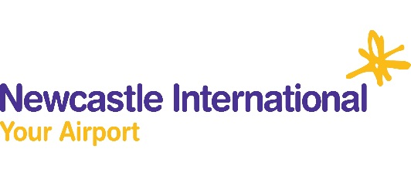
Newcastle International Airport
Winter Opening Hours
 | Monday | Tuesday | Wednesday | Thursday | Friday | Saturday | Sunday
Bar 11 | 5am – 7pm | 4.30am – 7.30pm | 4.30am – 7.30pm | 4.30am – 7pm | 4.30am – 7pm | 4.30am – 3.30pm | 4.30am - 9pm
Beer House | First - last flight | First - last flight | First - last flight | First - last flight | First - last flight | First - last flight | First - last flight
Boots | 4am – 8.30pm | 4am – 8.30pm | 4am –8.30pm | 4am – 8.30pm | 4am – 8.30pm | 4am -6.30pm | 4am -8.30pm
Burger King | 7am – 9pm | 7am – 7.30pm | 7am - 7pm | 7am – 6.30pm | 5am - 8pm | 7am – 4pm | 7am - 6pm
Cabin Bar | 5.30am - 7pm | 5.30am - 7pm | 5.30am - 7pm | 5.30am – 7pm | 5.30am – 7pm | 5.30am – 4.30pm | 5.30am – 4.30pm
Café Ritazza | 4am – 7.30pm | 3.30am - 7pm | 4am - 7pm | 4am - 7pm | 4am - 7pm | 3.30am - 4pm | 4am - 7pm
Flying Hippo | 4.30am – 7.30pm | 4am – 7.30pm | 4.30am - 8pm | 4.30am – 7.30pm | 4am – 7.30pm | 3.30am - 3pm | 4.30am – 7pm
Naked Deli | 5am – 7pm | 5am – 7pm | 5am – 7pm | 5am – 7pm | 5am –7pm | 5am – 7pm | 5am – 7pm
Pitta & Brew | 5.30am – 5.30pm | 5.30am – 5.30pm | 5.30am – 5.30pm | 5.30am – 5.30pm | 5.30am – 5.30pm | 5.30am – 2.30pm | 5.30am – 5.30pm
Upper Crust | 5am - 6pm | 5am - 6pm | 5am - 6pm | 5am - 6pm | 5am - 6pm | 5am - 3pm | 5am – 5.30pm
WHSmiths | First - last flight | First - last flight | First - last flight | First - last flight | First - last flight | First - last flight | First - last flight
World Duty Free | First - last flight | First - last flight | First - last flight | First - last flight | First - last flight | First - last flight | First - last flight

*Timetable may be subject to change depending on flight schedules

