**ABOUT HIDDEN DISABILITIES**

People often ask what the term *invisible disability* means. To define invisible disability in simple terms is a physical, mental or neurological condition that limits a person’s movements, senses, or activities that is invisible to the onlooker. Unfortunately the very fact that these symptoms are invisible, can lead to misunderstandings, false perceptions and judgments.

The term *invisible disabilities* refers to symptoms such as debilitating pain, fatigue, dizziness, cognitive dysfunctions, brain injuries, learning differences and mental health disorders, as well as hearing and vision impairments. These are not always obvious to the onlooker, but can sometimes or always limit daily activities, range from mild challenges to severe limitations and vary from person to person.

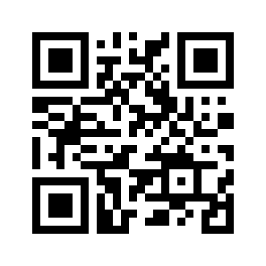

**AIRPORT** HIDDEN DISABILITY PASSPORT

**ABOUT ME**

Name: ______________________________________________

Address: __________________________________________________________________________________________________________________________________________

Post Code: ______________________________________________

Email: ______________________________________________

Telephone: ______________________________________________

Date of Birth: ______________________________________________

My condition is: ____________________________________________________________________________________________

Emergency contact: ______________________________________________

**Factors in the airport that may make me anxious:**

Situations I find difficult: ______________________________________________________________________________________________________________________________________________________________________________________________________________________________________

____________________________________________________________________________________________

Things that would help me (reasonable adjustments):

____________________________________________________________________________________________________________________________________________________________________________________________________________________________________________________________________________________

DISCLAIMER - *This passport is the property of the individual named in this document and can only be shared with their permission.*