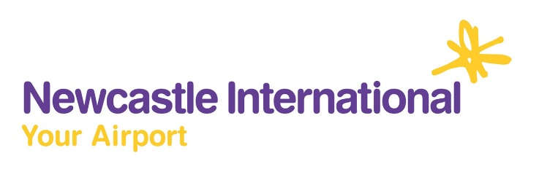

Newcastle International Airport

Environmental Policy 2015

Scope:
Newcastle International is the largest airport in the North East and handles over 4 million passengers a year. The airport site also has numerous business partners, including airlines, handling agents, retail and catering units and freight operators. We are committed to ensuring that the airport is run in a way that has a minimal impact on the environment.

The following are areas that Newcastle International will specifically address:-

Water Quality – to protect local watercourses from its activities including aircraft and pavement de-icing, chemical storage and fire station exercises. This will be managed through an on-going monitoring regime.

Noise – to seek to mitigate the noise impacts of its activities through air traffic and airfield management, monitoring and communication.

Waste – to work to adopt best practice standards in sending no waste to landfill, by increasing recycling on site and diversion to ‘Energy from Waste’ sites.

Energy – to monitor energy use and identify areas where improvements can be made, and to encourage staff and business partners involvement in making the airport more efficient.

Air Quality – to identify and mitigate the local air quality impacts of the airport’s activities, including to continuously monitor nitrogen dioxide levels across the site.

Landscape & Wildlife – to ensure that all impacts on local flora and fauna are considered in any development proposals.

Environmental Management – to comply with applicable legislation and other standards associated with our industry, and to strive for continual improvement in our environmental performance.

This policy will be reviewed on a regular basis to ensure that it is still relevant to the airport’s activities.

